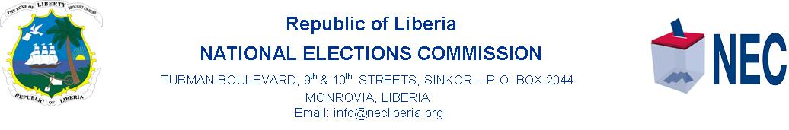
Public Service Announcement

NEC/6 August 2020
NEC Extends Deadline for the Submission of Political Parties Technicians for the Review of the 2017 FRR to NEC
The National Elections Commission (NEC) informs Registered Political Parties, Local and International Observers that the deadline for the Nomination of Technicians to the Review Process of the 2017 Final Registration Roll (FRR) and their involvement in the 2020 Voter Roll Update is extended from today, Thursday, 6 August 2020 to Monday, 10 August 2020.
The extension of the deadline is due to the importance of ensuring the participation of Political Parties’ Technicians in the review of the 2017 Voter Roll Update.
According to the NEC, the current Review Process of the 2017 Voter Roll is in fulfillment of the Joint Resolution, #003/2020 of the National Legislature to include Political Parties and Observers in this exercise.

Signed By: ________________________.
Henry Boyd Flomo
Communication Director

To: Anthony Sengbe
Executive Director

From: Henry Flomo
Communications Director

Subject: As Indicated Below

Date: 6 August 2020

Kindly approve the amount of One Hundred and Fifty United States Dollars, (USD150, 00) for five days Public Service Announcements (SPOTS) for the extension of the involvement of Nominated of Technicians m Political Parties Technicians.

The five-day Spot PSA will be aired on ELBC Radio from today, 6 August 2020 to Monday, 10 August 2020.

Please be reminded Sir, that this PSA is urgent in line with ensuring that the Joint Resolution of the National Legislature for the Voter Roll Update if full implemented.

